The 2020 Wendy McDonald Diversity Awards
Diversity Champion
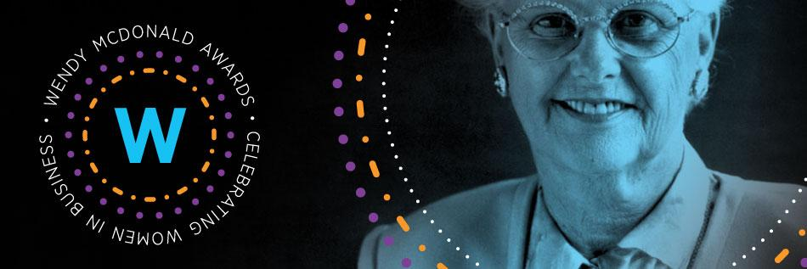
The Greater Vancouver Board of Trade’s (GVBOT) Women’s Leadership Council (WLC) is proud to announce the 6th annual Wendy McDonald Diversity Awards.
The WLC is an inclusive program that works to promote increased gender diversity in leadership in the B.C. business community. Launched in 2007, the WLC has grown to become one of the largest women's business networking groups in Canada.
Wendy McDonald:
Wendy McDonald was an indomitable force in Canadian business and a pioneer for women in leadership. Despite facing great adversity throughout her life, Wendy found the courage and confidence to grow a business empire in a male-dominated industry. After only two years at the helm of BC Bearing Engineers Ltd., Wendy doubled the size of her company to become the largest independent industrial bearing specialist in Western Canada. As CEO, Wendy’s leadership and determination transformed her company from a local business into a global competitor in the industrial bearing market. By the time Wendy retired in 2000, the business had grown to 60 locations worldwide.
Wendy McDonald was an advocate for the growth and prosperity of the Greater Vancouver business community. In 1990, Wendy served as the first female chair of the GVBOT. A true entrepreneur who was not afraid to take chances, Wendy was one of the original investors in the Vancouver Whitecaps. Wendy won numerous awards throughout her career and in 1997 she was named to the Order of Canada.
“You can do anything you want if you have the heart.” This quote by Wendy embodied her drive and commitment and was forever imparted by Wendy on the many people she met.
About the Wendy McDonald Diversity Awards:
The purpose of the Wendy McDonald Diversity Awards is to recognize individuals who embody the outstanding qualities that enabled Wendy McDonald to succeed. Each of the awards represents one of the outstanding qualities possessed by the late Wendy McDonald. These qualities were developed as she chose to step fully into and rise to the challenge of being a single mom running a company in a male dominated industry.
With each of these awards, the GVBOT WLC is choosing to focus its lens on the determination, courage and bravery of the not yet recognized or unsung heroes among us. When Wendy first began her journey, she was unrecognized and may have benefitted from attention drawn to her good work and community impact. We wish to support those who are quietly making a difference in all corners of our community.

In your nominations, we ask you to consider highlighting the hidden gems behind some of the biggest advances in our five categories. We look for local impact first and global impact second. Complete and competitive applications include quantitative and qualitative data points.
Diversity Champion  The nominee is a champion of diversity and equality at an organizational level. This individual promotes systemic change within their organization, field or industry and leverages gender diversity to help advance their business strategy in the Greater Vancouver community. Local impact will be acknowledged first. Nominees of all gender and all ages are being accepted for this award. | Community Catalyst  The nominee has demonstrated a positive and tangible impact or affected change in the (local) Greater Vancouver community. Through their dedication to creating opportunities, programs and initiatives they have improved the lives and status of women in our community. Impact beyond their employment is considered important criteria. Nominees of all gender and all ages are being accepted for this award. |  | Entrepreneurial Innovation  Recognizes a female business leader who has become a successful job creator and significant contributor to the economy of Greater Vancouver through her entrepreneurial creativity, initiatives and innovative business practices. Female and female identified nominees of all ages are being accepted for this award.
Outstanding Mentor/Sponsor  The nominee established a clear and direct mentoring or sponsoring relationship with one or more female or female identified mentees and through these relationships, guided their mentees to significant career growth over their time together. Nominees of all gender and all ages are being accepted for this award. |  | Women to Watch  Recognizes a female and female identified future leader under the age of 35 as of March 13, 2020 in the early stages of her career who has made a difference in her organization, field or industry, exhibiting undeniable promise for her future impact on the local community in Greater Vancouver.

Eligibility Criteria:

- Nominees must be based in British Columbia.
- Women to Watch nominees must be in the early stages of their careers and 35 and under as of March 13, 2020
- Nominees of all genders will be accepted for Diversity Champion, Outstanding Mentor/Sponsor and Community Catalyst. All other categories are open to female and female identified nominees only.
- Nominators may submit nominations for more than one individual.
- Self-nomination will not be accepted.
Winners Receive:
- Media exposure in Sounding Board – distributed through Business in Vancouver newspaper – and a profile on the GVBOT website, boardoftrade.com.
- Meeting with a prominent Greater Vancouver Board of Trade Director, Governor, or WLC Advisory Committee member.
- Two complimentary tickets to a GVBOT event of your choice, *excluding marquee events*.
- Recognition at an awards reception event on May 27, 2020.

Diversity Champion Application Form:
This category is open to nominees of all genders.

All nomination forms must be submitted to programs@boardoftrade.com by
9 a.m., Friday, March 13, 2020. 9 a.m., Friday, March 20, 2020.
Please complete all questions below. In order to be equitable to all nominees, the judging committee will not consider any information outside of this nomination form when selecting the winners in each category, including resumes, public profiles, or personal knowledge of the judging committee. Please do not submit any other materials with this nomination form. For this reason, it is important to provide robust and detailed answers in your nomination.
Please note that winners are expected to attend the awards reception event on May 27, 2020.

* Please note the WLC reserves the right to ask the nominator to re-submit their nomination if they feel that the nominee would be better suited to a different category.

- Nominee Information

Full Name | < please answer here>
Mailing Address  (Street, City, Postal Code) | < please answer here>
Telephone Number | < please answer here>
Business Phone Number (Please include ext.) | < please answer here>
Email Address | < please answer here>
Organization | < please answer here>
Position | < please answer here>
Date of Birth: DD-MM-YYYY  (For Women to Watch nominees only) | < please answer here>

- The Nominee identifies as:

☐ Female
☐ Male
☐ Other

- Please describe and provide two specific examples of what the nominee has done to promote diversity, inclusion and equality in their organization, field, or industry. (e.g. reform, restructure or create programs or change systems.) Consideration of the nominee’s impact will be ranked with highest priority given to local impact followed by provincial, national or international.

< Please answer here in 300 words or less. Note that competitive applications typically have answers with at least 250 words.>

- Please describe based on the information/examples provided, the impact that this individual has had in promoting systemic change in their organization, field or industry. (e.g. more women in leadership positions, more women in the field or more diverse female identified voices at the tables of power.) Where appropriate, please provide quantitative measurements of the nominee’s impact.

< Please answer here in 300 words or less. Note that competitive applications typically have answers with at least 250 words.>

5. Please share two ways in which your nominee exemplifies Wendy’s spirit and credo?

Wendy was an exceptional representative of women’s leadership and through these awards her legacy will continue to pave the way for emerging women in business.

< Please answer here in 300 words or less. Note that competitive applications typically have answers with at least 250 words.>

- Nominator Information
Please fill out your own contact information.

Full Name | < Please answer here>
Mailing Address  (Street, City, Postal Code) | < Please answer here>
Telephone Number | < Please answer here>
Business Phone Number  (Please include ext.) | < Please answer here>
Email Address | < Please answer here>
Organization | < Please answer here>
Position | < Please answer here>
How did you hear about the Wendy McDonald Diversity Awards? | < Please answer here>

7. If the person you have nominated is selected as a winner, we will be checking references to verify their achievements. Please provide the contact information of two people who can act as a reference on behalf of your nominee.

Primary Reference
First and Last Name | < Please answer here>
Phone Number | < Please answer here>
Organization | < Please answer here>
Position | < Please answer here>
Relationship to Nominee | < Please answer here>
Secondary Reference
First and Last Name | < Please answer here>
Phone Number | < Please answer here>
Organization | < Please answer here>
Position | < Please answer here>
Relationship to Nominee | < Please answer here>

8. By checking "Yes", I confirm that the nomination I am submitting is accurate and reflective of the nominee for the Wendy McDonald Diversity Awards.

☐ Yes
☐ No

